**Fourier Decomposition/Transform:**

We’ve seen one technique to get features from time series data using window, now we’ll see another method called Fourier Transform.

Some used terms:

**Time Period:** it’s the time required to complete one oscillation of a wave.

**Frequency:** It’s shows how many oscillations were made in 1sec. If there is one oscillation per second then it has 1 Ghz frequency, if there are two oscillation in one second then it has 2 ghz frequency. It can also be seen as 1/T..

**Amplitude:** It’s the peak we get in a wave.

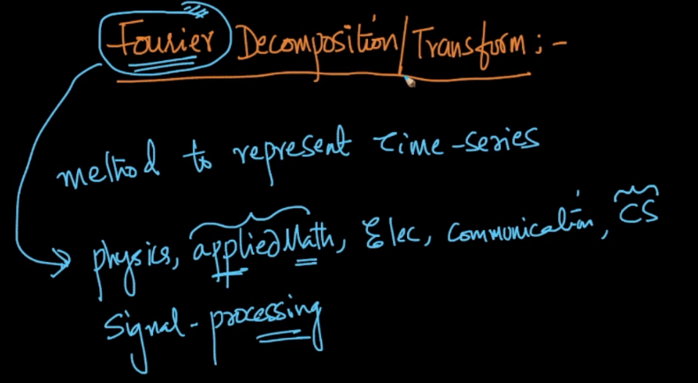

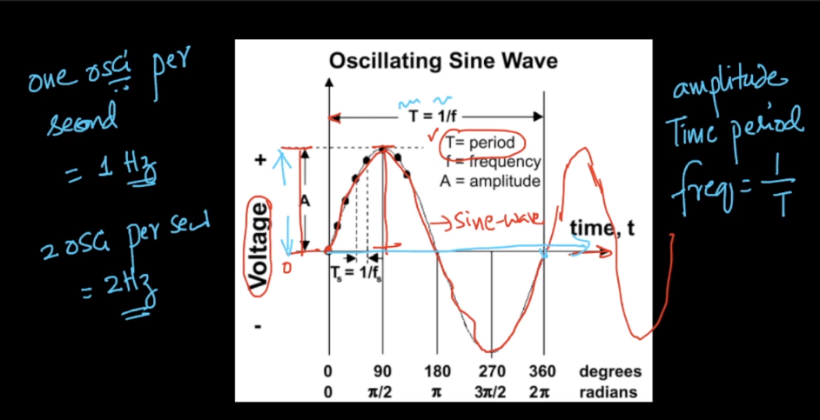

Example of frequency:

General heart beat range is 60-100 beats per minute, that means there are 1-1.6 beats per second or we can say frequency is 1 Ghz to 1.6 Ghz.

So if a heart beat decreases, then frequency will decrease which tells either there is some problem or person is sleeping.

And if heart beat increases over 100 bpm, then frequency will also become greater than 1.6 GHz which tells either there is problem or person is exercising.

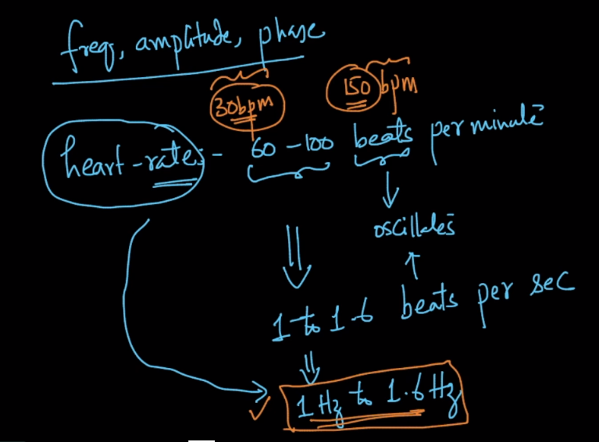

**Phase:**

It’s shown in below image.

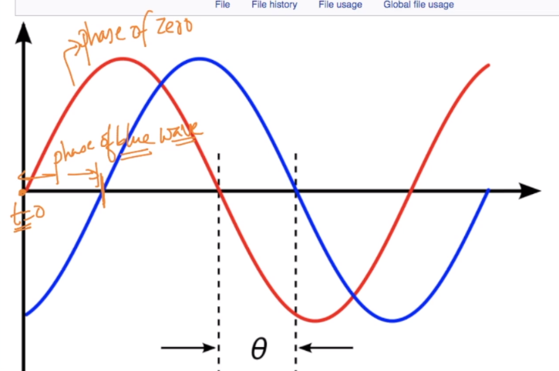

example: there can be a daily phase, where certain pattern is repeating after each day,

it can be weekly where pattern will occur week by week.

Or it can be annual, ex: amazon sale is highest on Diwali.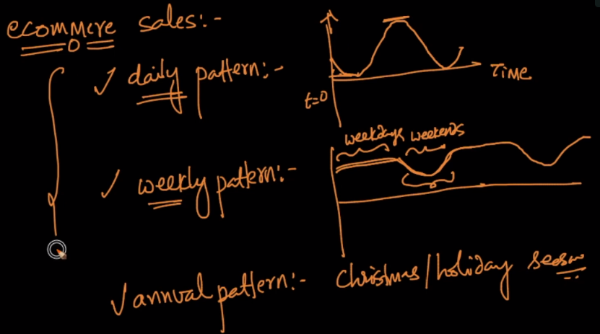

Let’s understand Fourier Transform:

FT converts a wave into more than one wave, where original wave is a composition of all the waves generated.

Below image shows FT generates 3 wave each have different frequency and amplitude.

Since with each wave there is a parameter attached called frequency and wave, therefore we can use them as features.

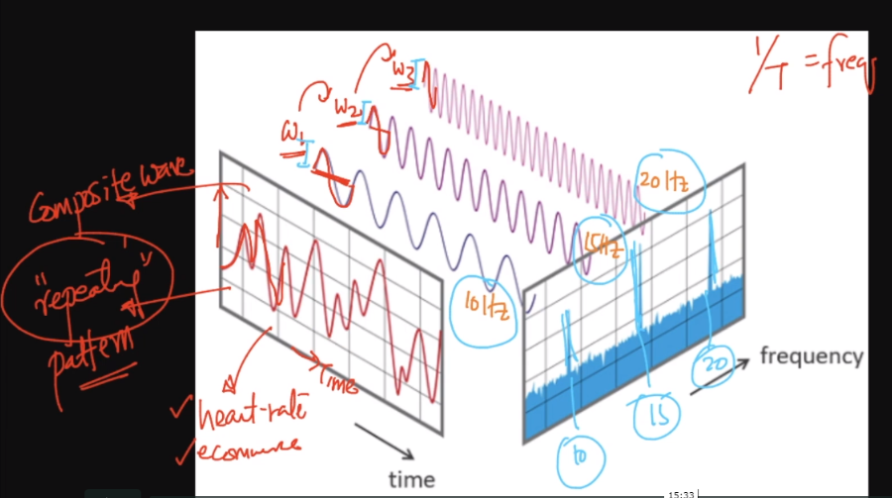

Here we have 3 waves so there will be 6 features, 1 ampltiude and 1 frequency for each of the 3 generated waves.

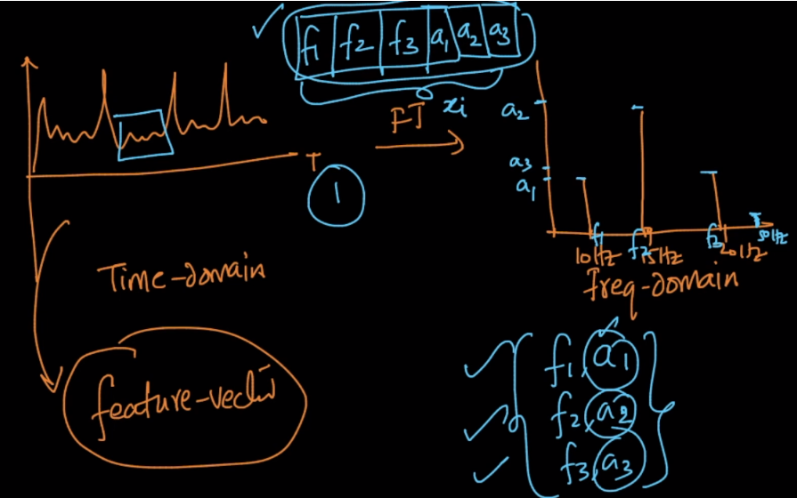

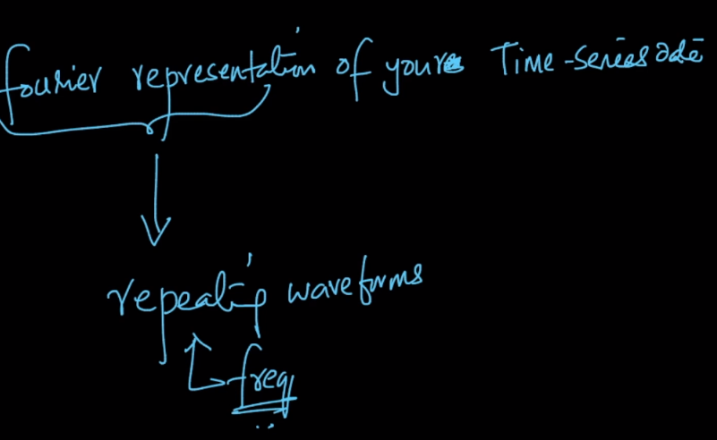

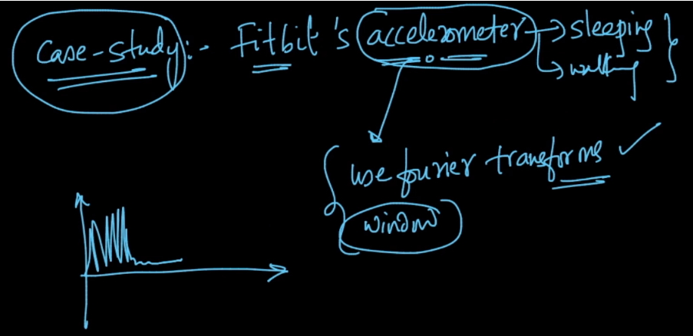

<http://ataspinar.com/2018/04/04/machine-learning-with-signal-processing-techniques/>

link which contain example for FT..

<https://www.ritchievink.com/blog/2017/04/23/understanding-the-fourier-transform-by-example/>

